This picture captures the goal of this lesson: if you know a car's heading (theta) and distance traveled (D), how can we figure out how far it's moved in the x direction (delta x) and y direction (delta y)?

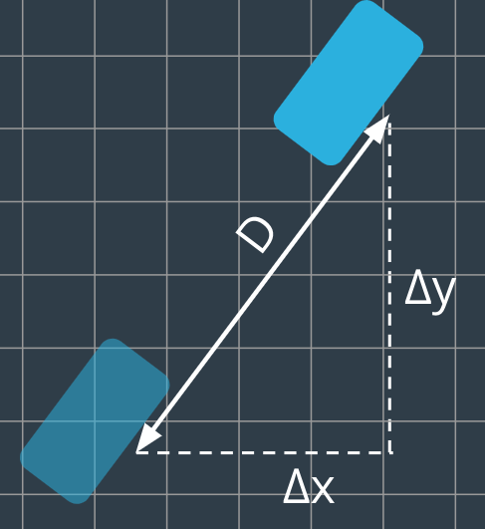

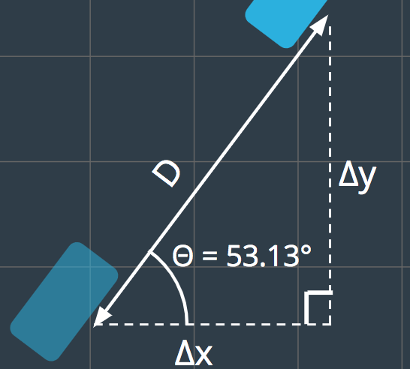

The following questions are about a right triangle where \Theta = 53.13 ^{\circ}Θ=53.13∘

You saw earlier that if D=5*D*=5, then

\Delta x = 3Δ*x*=3

and

\Delta y = 4Δ*y*=4

**Who Cares about 53.13 Degrees?**

You just calculated the following values for a vehicle with a heading of 53.13 degrees

| D*D* | \Delta yΔ*y* | \Delta xΔ*x* |
| --- | --- | --- |
| 5 | 4 | 3 |
| 10 | 8 | 6 |
| 1 | 4/5 | 3/5 |

But really, for this particular angle we can say something much more *general*. We can say:

\Delta y = \frac{4}{5}\times DΔ*y*=54​×*D*

\Delta x = \frac{3}{5}\times DΔ*x*=53​×*D*

And these are **very** useful equations! They tell us that the **vertical** displacement is equal to **total** displacement times some multiplier (in this case ⅘). Likewise, horizontal displacement is total displacement times some other multiplier (in this case ⅗).

And this is useful.... for all those times when you're driving at 53.13 degrees?

What about **every other possible angle**? Wouldn't it be nice to calculate these multipliers for any angle?

I make a mistake here when I talk about the multipliers. If your heading is 53.13 degrees then \Delta x = \frac{3}{5} \times DΔ*x*=53​×*D* and \Delta y = \frac{4}{5} \times DΔ*y*=54​×*D*.

I accidentally swapped these multipliers in the video.

### SOH - CAH - TOA

The **sine**, **cosine**, and **tangent** are all trigonometric ratios. A helpful mnemonic for remembering which sides each of these ratios compare is **SOH - CAH - TOA**

**SOH** - **s**ine is **o**pposite over **h**ypotenuse

\sin(\theta) = \frac{\text{opposite}}{\text{hypotenuse}}sin(*θ*)=hypotenuseopposite​

**CAH** - **c**osine is **a**djacent over **h**ypotenuse

\cos(\theta) = \frac{\text{adjacent}}{\text{hypotenuse}}cos(*θ*)=hypotenuseadjacent​

**TOA** - **t**angent is **o**pposite over **a**djacent

\tan(\theta) = \frac{\text{opposite}}{\text{adjacent}}tan(*θ*)=adjacentopposite​

Andy mentions the Nanodegree Slack near the end of this video - you can leave your questions in the Student Hub now!